HILLY FIELDS FOOTBALL CLUB
SEASON 16: 1982-83
Hilly Fields Old Boys Friendly
P W D L F A
Hilly Fields 1st XI 1 0 0 1 2 4

Apps Gls

Ron Davis 1 0
Martin Formosa 1 0
Len Franklin 1 0
Larry Garnham 1 0
Chris Green 1 2
Ray Griffin 1 0
Bobby Head 1 0
Ray Laroche 1 0
John Macrea 1 0
Frank Marsh 1 0
Ian Parsons 1 0
Tom Pollard 1 0
Frank Ryan 1 0

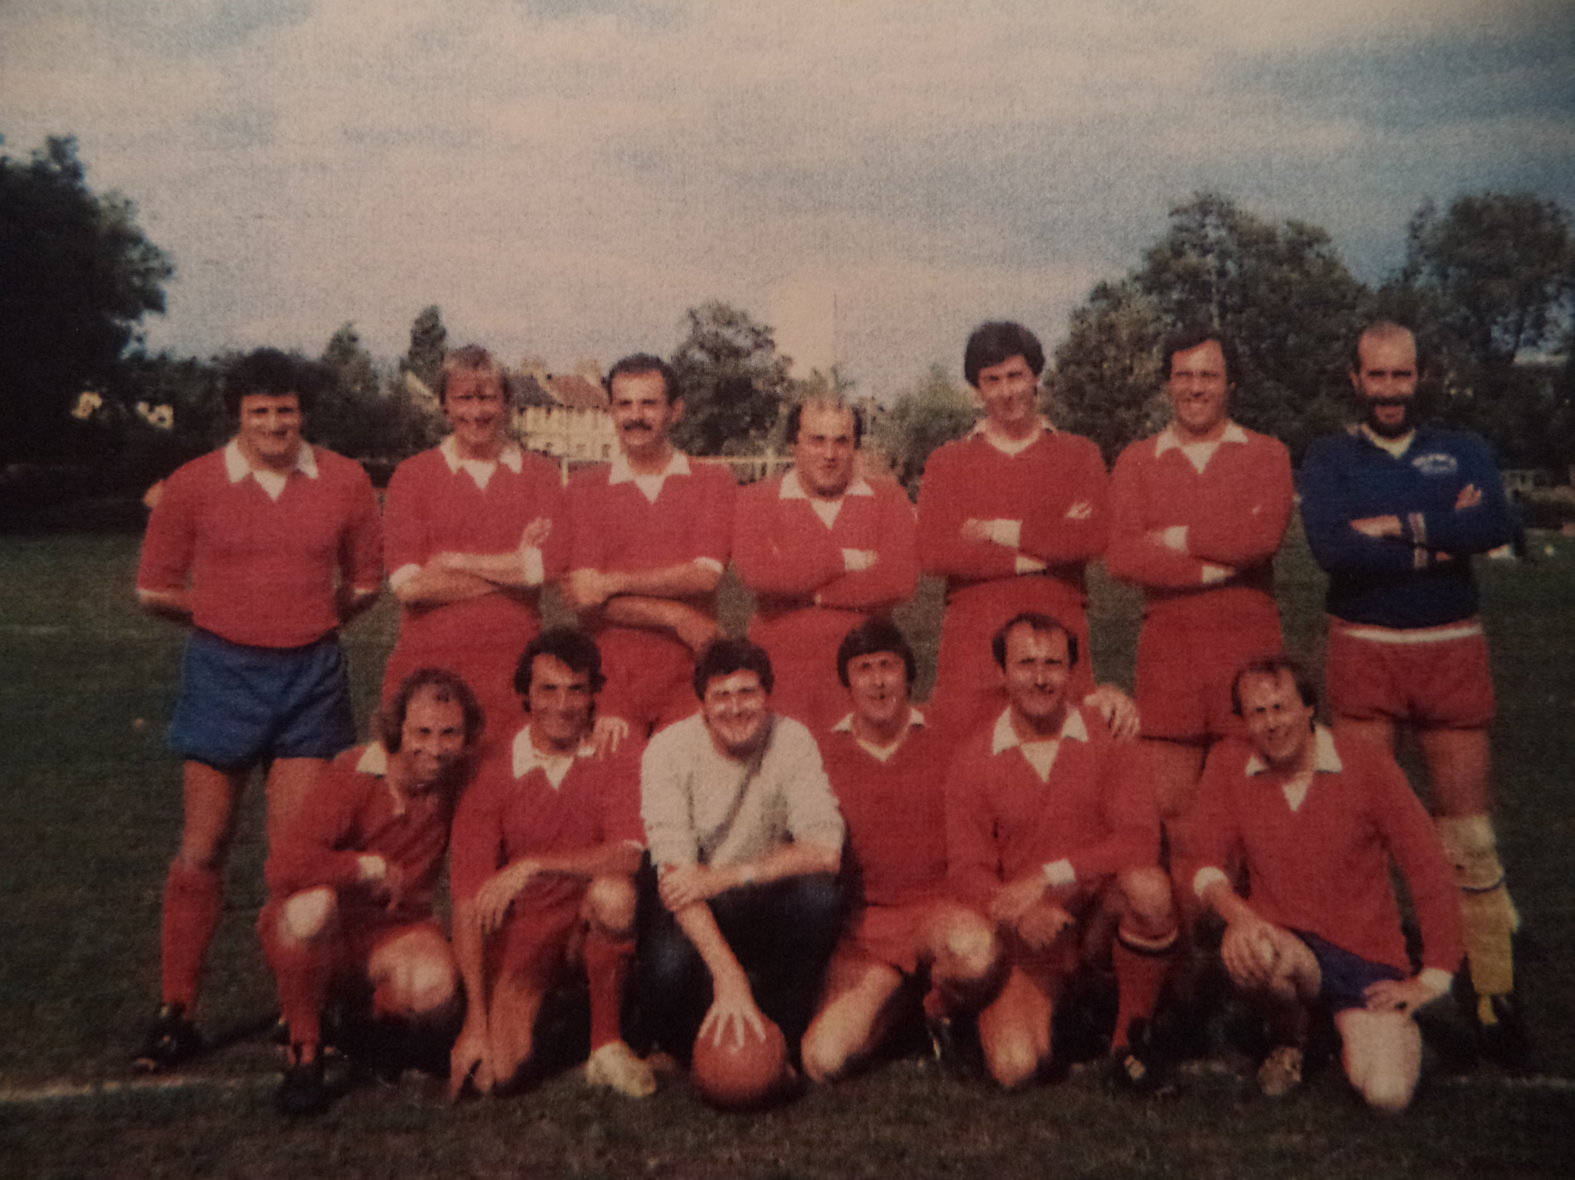

L-R Back: Bobby Head, Larry Garnham,Ian Parsons, Martin Formosa, Frank Ryan, Ray Laroche, John Macrea
L-R Front: Chris Green, Frank Marsh, Len Franklin, Ron Davis, Tom Pollard, Ray Griffin

